*Florida International University*

*School of Computing and Information Sciences*

Software Engineering Focus

Feature Document

User Story ID #132

**Name:** Register Profile

**Team Member(s):** Winicius Siqueira, Alfredo Morales

**Project:** Fellowship Management 1.0

**Product Owner(s)**: Robert Zurita

**Mentor(s)**: Mohsen Taheri

**Instructor**: Masoud Sadjadi

**User Story Name: Register Profile**

* As a user I would like to register a profile so that I can add fellowships to my account.

Acceptance Criteria

* A user can create a profile.
* A user is given an error if the profile username already exists.
* A user can login to the created profile.

**Use Case**

* Name: Register Profile
* Actor: Regular User
* Preconditions: The user has clicked the “Create Profile” link
* Description <Flow of events>: If the regular user types in a username that is already taken and submits the form, then no profile is created. The regular user is prompted to enter a username that is not taken. The user types in a username that is not taken and submits the form. A profile is created. The user can login to his/her newly created profile.

**Use Case Diagram <**you can use draw.io**>**

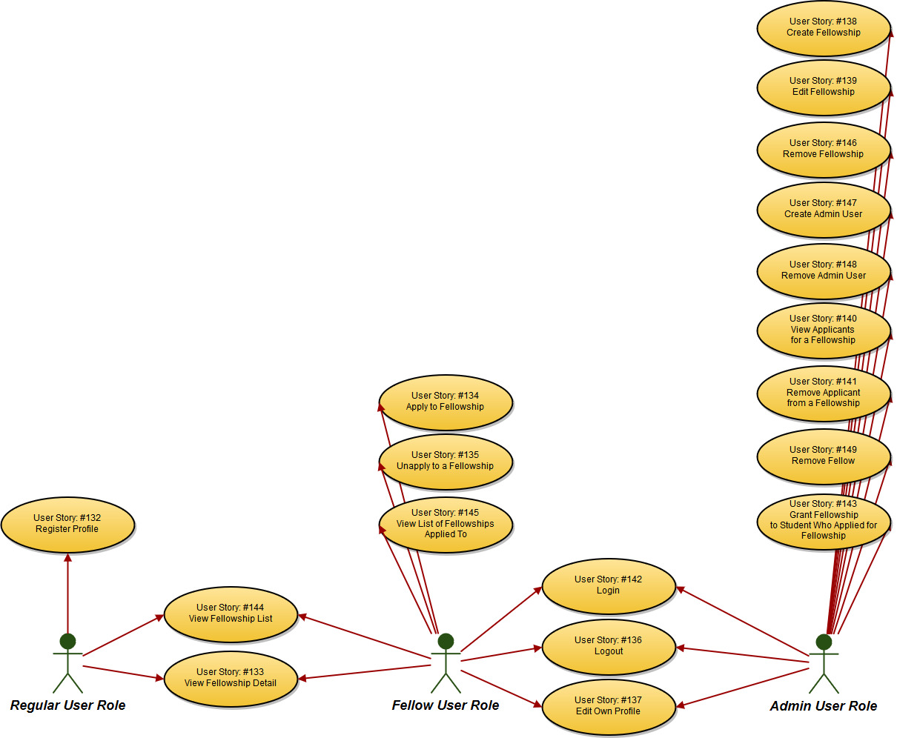

**Sequence Diagram**

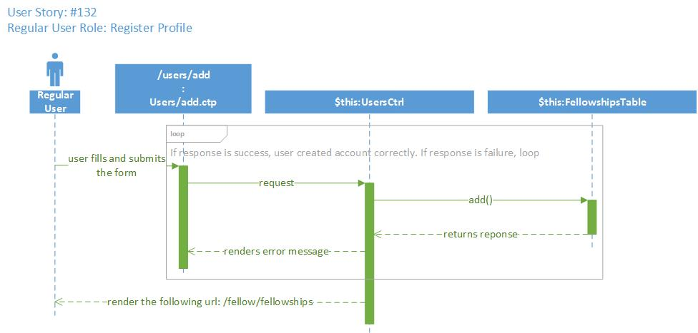

**Class Diagram**

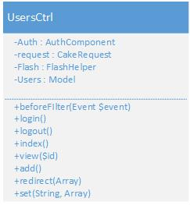

**Unit Test**

* Test case ID:
* Description/Summary of Test:
* Pre-condition:
* Expected Results:
* Actual Result:
* Status (Fail/Pass):

**Integration Test**

**Visual User Guide** <like one or two screenshots of the feature. For the hardware project, a photo of device is required>